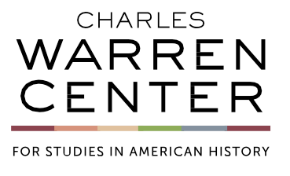








WORKSHOP ON CAPITALISM’S HARDWIRING

Simon Middleton
COLLEGE OF WILLIAM AND MARY

“Inventing Money in Early Pennsylvania.”

THURSDAY, MAY 4, 2023
1:30 P.M. – 3:30 P.M.
Harvard Law School
Wasserstein (ROOM TBD)

To access Professor Middleton’s paper visit warrencenter/event/middleton

For the paper’s password contact cwc@fas.harvard.edu

